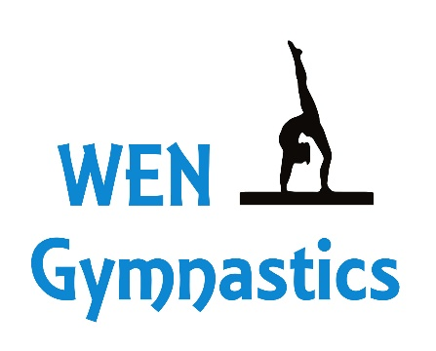
538 S. 5th Ave Oakdale, Ca 95361
209-847-6186
OWNER/ HEAD COACH: Wendy Wylie
Two Summer Gymnastics Camps!!
Check one or Both:
_______ June 22nd – 26th 2020 9am - 12pm
_______July 20th – 24th 2020 9am – 12pm
$150/Child/Camp payable by check to Wendy Wylie, cash, card, Venmo or Zelle
Ages 5-18 yrs. old - levels are beginning, intermediate and advanced
Registration DUE on or before the first day of camp. ALL member & Non-members will be required to have a waiver and release of liability on file.
Includes: 5 days of gymnastics – Vault, Bars, Beam & Floor
Stretching, Tumbling, Conditioning, learned routine, snack break & FREE give away
Check one: _______ Member _______ Non-Member
Participant Name:____________________________________________________________________
Gender: M F Birthdate: _______________________Age: ______________Grade: ___________
School:_____________________________________________________________________________
Adress:_____________________________________________________________________________
City:___________________________________State:______________________Zip:_______________
Medical Conditions:____________________________________________________________________
____________________________________________________________________________________
Parent/Gaurdian:______________________________________________________________________
Phone:____________________________Email:______________________________________________

